User Acceptance Testing (UAT) Template
Date | 30 August 2026
Project Name | Automated Network Request Management
Maximum Marks

Project Overview:
Project Name: Automated Network Request Management
Project Description:
Automated Network Request Management is a ServiceNow-based solution designed to simplify and automate the process of handling network requests. Users can submit network requests through the Service Catalog, after which the system automatically creates request records and initiates the required approval process. Flow Designer is used to automate request processing, status updates, task assignment, and email notifications. The system reduces manual effort, improves request tracking, and ensures that network requests are processed in an organized and timely manner.
Testing Period: 20 August 2026 to 25 August 2026
Testing Scope:
The UAT covers the major functionalities of the Automated Network Request Management system.
Features and functionalities tested:
• Network request submission through Service Catalog
• Automatic request record creation
• Request validation and approval process
• Automatic task assignment and processing
• Request status updates
• Email notifications to users and approvers
• Request tracking and monitoring
• Request completion and closure
Requirements/User Stories covered:
• Users can submit network requests through the Service Catalog.
• The system automatically creates a request record after submission.
• Approvers can review and approve or reject requests.
• Approved requests are automatically processed.
• Users can track the current status of their requests.
• The system sends automatic email notifications for important updates.
• Completed requests are automatically updated and closed.
Testing Environment:
Parameter | Details
Application | ServiceNow – Automated Network Request Management
Environment | ServiceNow Zurich Personal Developer Instance (PDI)
URL/Location | ServiceNow PDI
Credentials | Not included in documentation for security reasons
Browser | Google Chrome
Testing Type | User Acceptance Testing

Test Cases:
Test Case ID | Test Scenario | Test Steps | Expected Result | Actual Result | Pass/Fail
TC-001 | Network Request Submission | 1. Open Service Catalog.  2. Select Network Request.  3. Enter required information.  4. Submit the request. | Network request should be submitted successfully and a request number should be generated.. | Network request was submitted successfully and a request number was generated. | Pass
TC-002 | Request Record Creation | 1. Submit a network request.  2. Open the Network Request table.  3. Search for the submitted request. | A network request record should be created automatically. | Network request record was created successfully.. | Pass
TC-003 | Automatic Record Creation | 1. Submit a Network Request.  2. Open the Network Database table.  3. Search for the submitted request. | A corresponding Network Database record should be created automatically. | Network Database record was created successfully from the submitted request. | Pass
TC-004 | Approval Processing | 1. Submit a Network Request.  2. Allow the configured Flow Designer workflow to process the request.  3. Review the approval action.  4. Process the approval decision. | The request should be sent through the configured approval process and the approval decision should be recorded. | Approval process was triggered and the request could be processed through the configured approval workflow. | Pass
TC-005 | Email Notification | 1. Submit a Network Request.  2. Allow the workflow to process the request.  3. Check the generated email notification. | An email notification should be generated with relevant request information. | Email notification was generated successfully with the request number and message details. | Pass
TC-006 | Request Status Update | 1. Process an approved request.  2. Update the request record.  3. Check the Work Status. | The request status should be updated according to the workflow. | Request status was updated successfully, including the configured Work In Progress status. | Pass

UAT Evidence – Test Execution Screenshots:
Figure 1: Successful Network Request Submission:
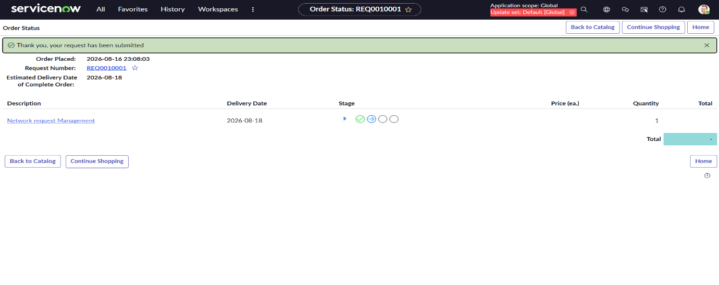Figure 2: Network Request Catalog Variables and Dynamic Fields
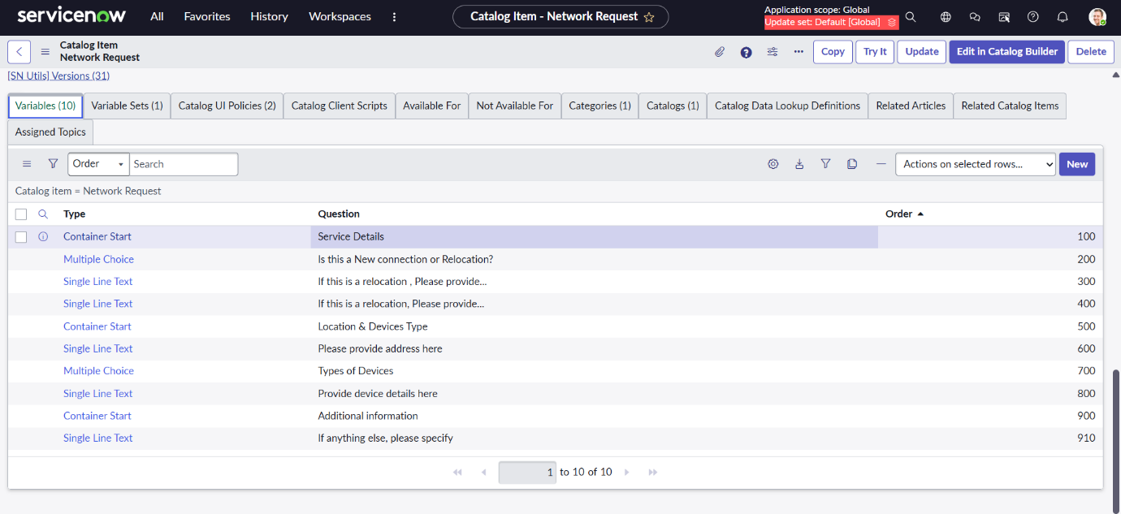
Figure 3: Automated Network Request Workflow
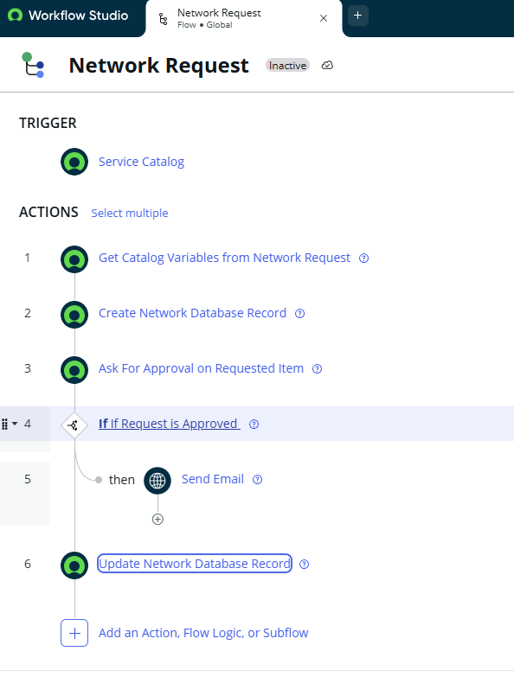
Figure 4: Email Notification for Network Request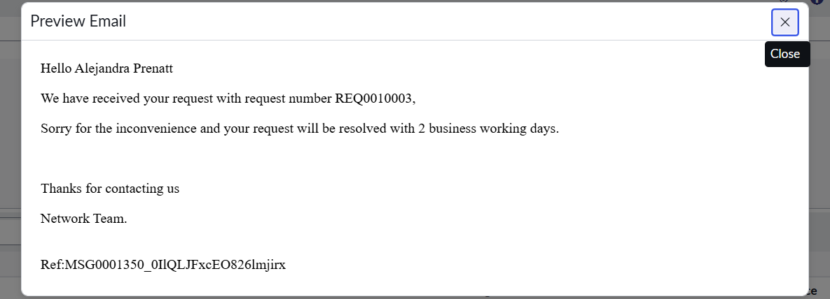
Bug Tracking:
Bug ID | Bug Description | Steps to reproduce | Severity | Status | Additional feedback
BG-001 | No major or critical defects were identified during testing of the automated network request workflow.. | Not Applicable |  |  | Request submission, automatic record creation, approval workflow, status updates, and email notifications worked as expected..
  —
  Closed

Sign-off:
Tester Name: Gonimilli Susmitha
Date: 26 August 2026
Signature: G.Susmitha
UAT Conclusion:
User Acceptance Testing was performed to verify that the Automated Network Request Management in ServiceNow meets its key functional requirements. The tested functionalities, including request submission, automatic request creation, approval, processing, status updates, and email notifications, worked as expected. The system met the defined requirements and provided an efficient and reliable way to manage network requests. Based on the UAT results, the project is considered ready for implementation.

